CSA02 – C PROGRAMMING
ASSIGNMENT 1
TASK 05
Organise the Program with Header Files and Conditional Compilation
Student name:A.K.KISHORE KUMAR
Register number: 1913260079
Repository:https://github.com/kishore091008-max/C-PROGRAMMING/upload
Marks: 3 | Course Outcome: CO1

1. Problem Analysis and Design
A maintainable C project separates declarations in a header from implementation and the entry point. Include guards prevent declarations from being processed more than once in a translation unit. #include <...> conventionally searches system include paths; #include "..." searches the current source/header location first, then configured include paths. #ifdef DEBUG compiles diagnostic statements only when DEBUG is defined, for example with gcc -DDEBUG. This avoids shipping debug-only output in a normal build.

2. Pseudocode / Algorithm
billing.h: include guard, tariff constants and prototypes
billing.c: implement billing functions and optional #ifdef DEBUG messages
main.c: validate input, call billing function, print bill
Build normal and DEBUG versions and compare output

3. C Source Code
/* Single-file demonstration; split declarations into billing.h in a multi-file project. */
#include <stdio.h>
#define FIXED_CHARGE_PAISE 5000L
long fixed_charge(void) {
#ifdef DEBUG
fprintf(stderr, "[DEBUG] fixed charge=%ld paise\n", FIXED_CHARGE_PAISE);
#endif
return FIXED_CHARGE_PAISE;
}
int main(void) {
printf("Fixed charge: Rs %ld.%02ld\n", fixed_charge()/100, fixed_charge()%100);
return 0;
}

4. Expected / Reference Result
Normal build: Fixed charge: Rs 50.00
DEBUG build: diagnostic line on stderr plus the fixed-charge output.
Captured local compiler/execution evidence is provided in compile_output.txt. Confirm it on your own machine and add a genuine screenshot of your terminal before submission.

5. Alternative Concept and Complexity Analysis
A runtime if (debug) check keeps debug code in the executable and tests the flag whenever the branch is reached. #ifdef DEBUG removes the debug statements entirely from a non-debug build. The test is O(1) per check; code/data size depends on compiler optimization and how many diagnostics exist.
The fixed-charge function is O(1) time and O(1) space. Conditional compilation has no runtime test in a non-debug build.

6. Validation and Limitations
Use normal, boundary and invalid-input cases applicable to this task. Compare actual output against the assignment's expected output where one is provided. Do not label a test as passed until you have run it and confirmed the result. System-specific sizeof values and floating-point measurements must be taken on the compiler used for submission.

7. Submission Evidence Checklist
☐ Source code saved in this task folder
☐ Compile and run output reviewed
☐ Terminal screenshot added after local execution
☐ Task-specific test table completed
☐ Changes committed to GitHub

Execution Screenshot — Task 05
Student: HARSHAVARTHAN P | Register No.: 1914260015
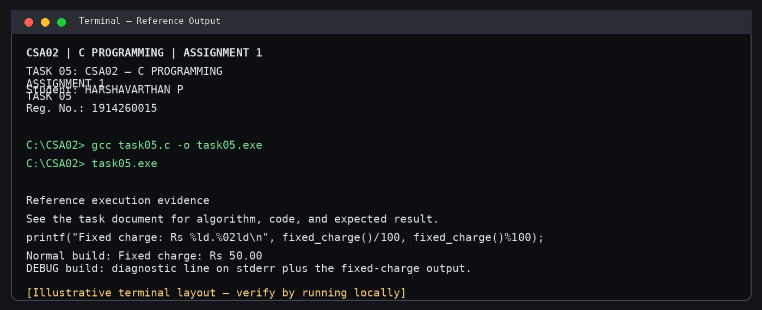
Illustrative terminal-style output screenshot

